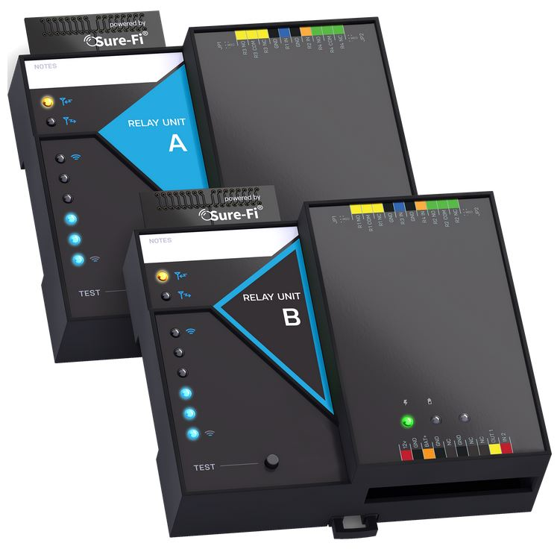

Operators Manual

Doc #PI0252 Rev 1.1

Quick Startup
The two units that are packaged together are factory paired and will only communicate with each other.

Check initial operation
Connect a 9V battery (not included) to the 9V cable (included) and plug the two-position connector in to the Unit A and Unit B interfaces at the ‘12V’ and ‘GND’ positions on the bottom edge connector. Once both units are powered up, the green POWER LED should be ON steady on each unit. Press and quickly release the ‘TEST’ button on either unit to test communication between the two units. One or more of the blue LEDs should light up for one second to indicate that successful communication has occurred.

Perform a Range-Test from the desired install locations
With the 9V batteries plugged in to each of the units, place them at the desired install location points and perform a Range-Test by pressing and quickly releasing the ‘TEST’ button. The received signal strength is displayed for one second on the six blue LEDs with the bottom LED indicating the minimum signal strength and all six LEDs indicating maximum signal strength.

Connect to permanent power
Before connecting each unit to the permanent power source, ensure that it is a 12VDC supply that can source at least 1 ampere to the unit. Connect the power at each unit and perform several Range-Tests to check for adequate input power.

Wire the input and output functions
Using this manual as a reference, wire the required devices at each unit.
The maximum voltage that can be applied to any input or output pin (IN1, OUT1, IN2, OUT2, R1IN – R4IN) is 5VDC.

Table of Contents
Part Numbers |  | Pg. 5
Overview |  | Pg. 5
Key Features |  | Pg. 5
General Specifications |  | Pg. 6
Radio Transceiver Specifications |  | Pg. 6
Device Overview, Unit A  Device Overview, Unit B |  | Pg. 7  Pg. 8
Unit A Interface – Top & Bottom Connector pin descriptions |  | Pg. 9
Unit B Interface – Top & Bottom Connector pin descriptions |  | Pg. 10
Providing Power |  | Pg. 11
Battery Backup Charging and UPS Functionality |  | Pg. 11
POWER LED and BATTERY LED Diagnostics/Flash codes |  | Pg. 12
Jumpers JP1 and JP2 (Unit B only) |  | Pg. 13
Relays: Operating the Relays, Relay Control |  | Pg. 14
Digital Inputs and Outputs (IN 1, IN 2 / OUT 1, OUT 2) |  | Pg. 14
Test (Range Test) Push Button |  | Pg. 14
LEDS: Power, Battery, Tx, Rx |  | Pg. 14
Antenna information |  | Pg. 15
Connector plug information |  | Pg. 15
Chain Multiple systems together for extended range |  | Pg. 15
Mounting |  | Pg. 16
Troubleshooting and manually testing the Relays |  | Pg. 18
Wiring Example for Unit A and Unit B |  | Pg. 19
Wiring Example of a Chained System for extended range |  | Pg. 20
Sure-Fi App, downloading, installing, connecting |  | Pg. 21
Sure-Fi App: Firmware Updating |  | Pg. 22
Sure-Fi App: Changing the name of the unit  Sure-Fi App: System Heartbeat and Relay Defaults |  | Pg. 22  Pg. 22
FCC and Industry Canada Regulatory Statements |  | Pg. 23
Warranty |  | Pg. 24

Figure Reference Guide
Figure 1: Device Overview, Unit A |  | Pg. 7
Figure 2: Device Overview, Unit B |  | Pg. 8
Figure 3: Providing Power: connecting power and Backup Battery |  | Pg. 11
Figure 4: JP1/JP2 Pinout diagram |  | Pg. 13
Figure 5: Diagram of Power Input, +VBUS, and JP1/JP2 functionality |  | Pg. 13
Figure 6: DIN Rail and screw mounting clips |  | Pg. 16
Figures 7 & 8: Top and Bottom DIN rail screw mount locations |  | Pg. 17
Figures 9 & 10: Wiring Example: Units A and B |  | Pg. 19
Figures 11: Chained Systems wiring |  | Pg. 20

Part Numbers
DS006-RELAY | Relay Bridge system: includes 1 ea. SFI-RB301-01 and SFI-RB302-01
SFI-RB301-01 | UNIT A
SFI-RB302-01 | UNIT B

Overview
The Sure-Fi DS006-RELAY Relay Bridge System consists of two units that are factory paired and ready to use out of the box with no configuration required. The system provides a wireless connection (bridge) from a remote location, such as a sensor control/monitoring location, to the paired unit placed at a central control area or monitoring panel. Each unit has two Form C relays that correspond with the two relay inputs from the paired unit. The Sure-Fi App provides for configuration, diagnostics, and field firmware updates.

Key Features
- Complete wireless solution for two relays in each direction between Unit A and Unit B
- Range: up to 1 mile through obstructions and greater than 50 miles line-of-sight
- Chain multiple system pairs for extended range
- Two relay outputs per unit NO, NC, COM terminals
- One digital input: dry contact or digital voltage interface (0 to 5VDC), corresponds with digital output from paired unit
- One digital output: digital voltage output (0 to 5VDC), corresponds with digital input from paired unit
- Backup Battery charger and UPS function
- DIN rail mount or direct wall mount
- Sure-Fi App connects via Bluetooth for configuration, diagnostics, and field firmware updates

General Specifications
Operating Voltage: 12VDC (9VDC to 15VDC)
Operating Current: @ 12VDC: 0.05A (idle), 0.3A (transmit)
Operating Power: 3.6 Watt (peak)
Battery backup: 12V sealed lead acid (SLA) type only (not included)
Battery Low Threshold: < 11VDC
Battery Charge Voltage: 13.75V maximum at standby charge.
Battery Charge Current: Trickle charge, 0.125A maximum at low battery voltage level
Relay Inputs (each unit): Two relay control inputs: dry contact or digital 0 to 5VDC interface
Digital Input/Output: Dry contact or 0 to 5VDC input interface. Output interface: 0 to 5VDC
Relays (Unit A): Two Form C mechanical relays, 2A 220VDC / 250VAC. Maximum switching power 60W/ 125VA, maximum combined current 3A
Relays (Unit B): Two Form C solid state relays, 2A 30VDC / 30VAC
Note: Maximum allowable combined current is 3A
Range: Up to 1 mile through obstructions. Greater than 50 miles line-of-sight
Can chain multiple system pairs for extended range
Encryption: AES128
Operating Temperature: -40°F to +185°F (-40°C to +85°C)
Storage Temperature: -67°F to +257°F (-55°C to +125°C)
Humidity: 0 to 85% non-condensing
Dimensions (L x W x H): 3.54” x 4.23” x 1.28” (90mm x 107mm x 32.5mm)
DIN mount type: 35mm DIN rail (DIN46277-3) / (DIN35)
Degree of Protection: IP20 to IEC/EN 60529

Radio Transceiver Specifications
Transmit Power: 1 Watt (30dBm)
Frequency Band: 902 – 928MHz
Channels: 72 (Frequency hopping)
Receiver Sensitivity: -133dBm
Link Budget: 163dB

Device Overview
Figure 1: Overview, Relay Unit A
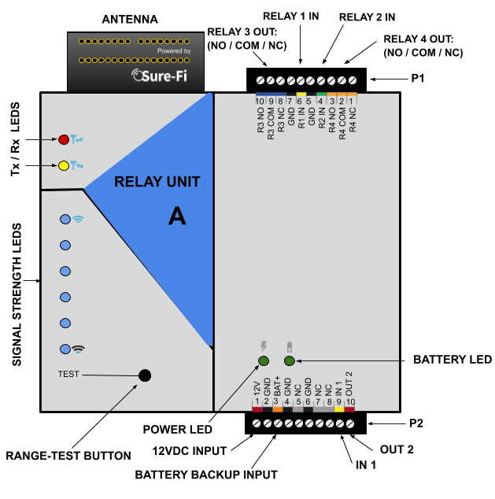

Device Overview
Figure 2: Overview, Relay Unit B
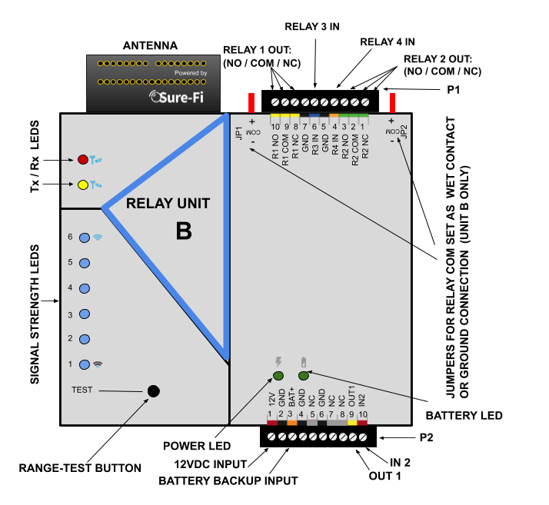

Unit A connectors
Table 1: Top Edge Connector P1. See Figure 1 for connector location and pin numbers
CONNECTOR | POSITION | NAME | DESCRIPTION
P1 | 1 (right end) | R4 NC | Relay 4 Normally-Closed terminal
P1 | 2 | R4 COM | Relay 4 Common terminal
P1 | 3 | R4 NO | Relay 4 Normally-Open terminal
P1 | 4 | R2 IN | Relay 2 control: activates Relay 2 on Remote unit
P1 | 5 | GND | DC Ground
P1 | 6 | R1 IN | Relay 1 control: activates Relay 1 on Remote unit
P1 | 7 | GND | DC Ground
P1 | 8 | R3 NC | Relay 3 Normally-Closed terminal
P1 | 9 | R3 COM | Relay 3 Common terminal
P1 | 10 (left end) | R3 NO | Relay 3 Normally-Open terminal

Table 2: Bottom Edge Connector P2. See Figure 1 for connector location and pin numbers
CONNECTOR | POSITION | NAME | DESCRIPTION
P2 | 1 (left end) | 12V | + DC input
P2 | 2 | GND | - DC input
P2 | 3 | BAT+ | Battery backup positive terminal ’+’ connection. 12V SLA type battery only.
P2 | 4 | GND | - DC input
P2 | 5 | NC | Not Connected
P2 | 6 | GND | - DC input
P2 | 7 | NC | Not Connected
P2 | 8 | NC | Not Connected
P2 | 9 | IN 1 | Digital Input 1, corresponds with digital output 1 (OUT 1) on Unit B
P2 | 10 (right end) | 0UT 2 | Digital Output 2, corresponds with digital input 2 (IN 2) on Unit B

Unit B connectors
Table 3: Top Edge Connector P1. See Figure 2 for connector location and pin numbers
CONNECTOR | POSITION | NAME | DESCRIPTION
P1 | 1 (right end) | R2 NC | Relay 2 Normally-Closed terminal
P1 | 2 | R2 COM | Relay 2 Common terminal
P1 | 3 | R2 NO | Relay 2 Normally-Open terminal
P1 | 4 | R4 IN | Relay 4 control: activates Relay 4 on Controller unit
P1 | 5 | GND | - DC input
P1 | 6 | R3 IN | Relay 3 control: activates Relay 3 on Controller unit
P1 | 7 | GND | - DC input
P1 | 8 | R1 NC | Relay 1 Normally-Closed terminal
P1 | 9 | R1 COM | Relay 1 Common terminal
P1 | 10 (left end) | R1 NO | Relay 1 Normally-Open terminal

Table 4: Bottom Edge Connector P2. See Figure 2 for connector location and pin numbers
CONNECTOR | POSITION | NAME | DESCRIPTION
P2 | 1 (left end) | 12VDC | + DC input
P2 | 2 | GND | - DC input
P2 | 3 | BAT+ | Battery backup positive terminal ’+’ connection. 12V SLA type battery only.
P2 | 4 | GND | - DC input
P2 | 5 | NC | Not Connected
P2 | 6 | GND | - DC input
P2 | 7 | NC | Not Connected
P2 | 8 | NC | Not Connected
P2 | 9 | OUT 1 | Digital Output 1, corresponds with digital input 1 (IN 1) on Unit A
P2 | 10 (right) | IN 2 | Digital Input 2, corresponds with digital output 2 (OUT 2) on Unit A

Providing Power
Each unit requires a 12VDC supply that can source at least 0.5A, but a 1A supply is always recommended to ensure adequate power. If a Maglock, Door Strike, or other device is to be powered through an on-board wet relay, then the additional power required for those devices will need to be considered when selecting a power supply. A battery backup can be connected as shown if required for the application.
Figure 3: Backup Battery Connection 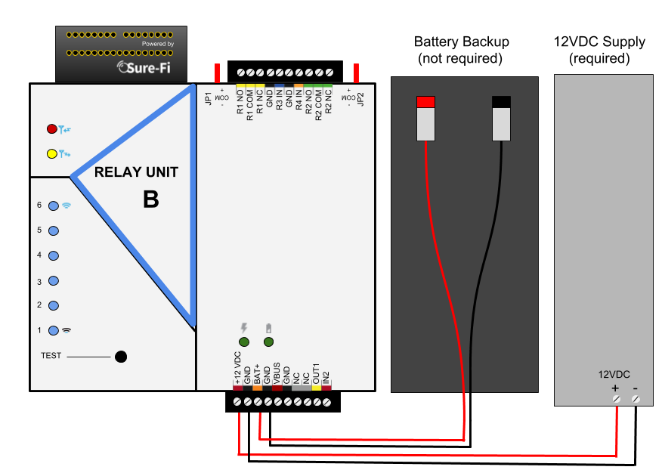

Battery Backup Charging and UPS Functionality
Both units provide a charging voltage for a 12V sealed lead acid battery backup and they also have uninterruptable power supply (UPS) functionality. The UPS will automatically switch to the battery backup whenever the 12VIN wall power goes out and will then switch back to the 12VIN wall power when it returns.

Power and Battery LED Diagnostics/Flash codes
The two green LED’s that are labeled ‘POWER’ and ‘BATTERY’ are used to provide the status of the 12VDC input power and the Battery input voltage. The LED status information is described here:
Power Status: POWER LED
LED STATE | DESCRIPTION
ON | Normal input voltage. Voltage is between 9VDC to 15VDC
Slow Flash (1Hz) | Detected input voltage is below 7VDC. Check for proper input voltage
Fast Flash (2Hz) | Detected input voltage is above 15VDC. Check for proper input voltage
OFF | No input power or device not functioning properly

Battery Status: BATTERY LED
LED STATE | DESCRIPTION
ON | Battery voltage normal
Slow Flash (1Hz) | Low battery voltage. Battery voltage is less than 11.0VDC
Fast Flash (2Hz) | Battery voltage high. Maximum Battery voltage is 13.8VDC
OFF | No battery connected: Detected battery voltage is less than 1VDC
NOTE: The POWER LED and BATTERY LED will flash in an alternating pattern if the input voltage drops too low during a radio transmission and is an indication that the power supply being used is faulty or under rated.

Jumpers JP1 and JP2 (Unit B only)
Jumpers JP1 / JP2 are used to connect the relay COM terminal to either GND or +VBUS. Connecting the jumper to the +VBUS creates a wet relay contact that can be used to source power to a device. JP1 is for Relay 1, JP2 is for Relay 2. Figure 4 shows the pinout of JP1/JP2. Use the supplied Jumper to connect the common terminal to either the – (GND) or the +(VBUS) pins if required for the desired application. The + VBUS is the same voltage that is present on the power input at the +12VDC input, or if the Backup battery is in use, on BAT+. The +VBUS is available on UNIT B bottom connector position 5 as an option to provide power to an external device. The Unit B is delivered with the supplied Jumpers on JP1 and JP2 set for a dry relay (COM not connected to either GND or +VBUS), see figure 5.
Figure 4: JP1 / JP2 Pinout 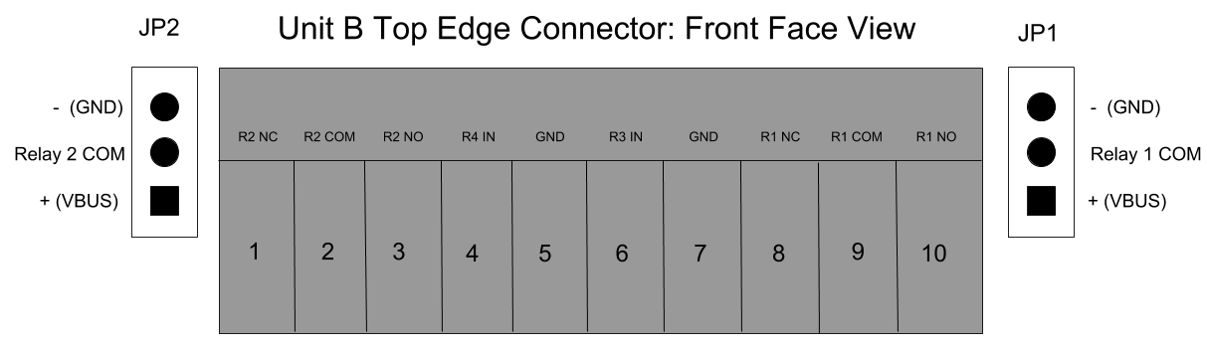

Figure 5: Diagram of Power Input, +VBUS, and JP1/JP2 functionality
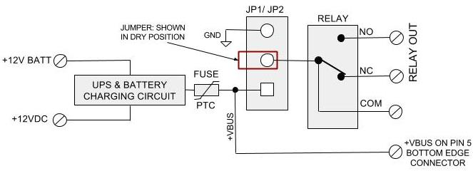

Relays
Operating the relays
The relay outputs are operated by the corresponding relay inputs that are on the paired unit. For example, to activate Relay 1 on Unit B, the Relay 1 input (R1 IN) on Unit A must be shorted to ground (0VDC) using either a dry relay contact or a switch to ground or a digital voltage 0 to 5VDC. This can be tested by connecting a switch to the Unit A R1 IN and GND or connecting them to an access panel output relay NO and COM terminals. When the switch or the access panel output relay closes, the R1 IN will be put to GND (0V) and will cause the Relay 1 output on Unit B to activate.

Relay control
Relay 1 & 2 Outputs located on Unit B are operated by R1 IN & R2 IN on Unit A.
Relay 3 & 4 Outputs located on Unit A are operated by R3 IN & R4 IN on Unit B.

Digital Input/Output (IN 1, IN 2 / OUT 1, OUT 2)

The IN 1 on Unit A corresponds to the OUT 1 on Unit B.

The IN 2 on Unit B corresponds to the OUT 2 on Unit A.

The IN 1 and IN 2 inputs are ‘active low’ type inputs and are interfaced in the same way as the Relay control inputs, by shorting to GND using either a dry relay contact, switch, or interfacing with a digital voltage input 0 to 5VDC.

The ‘Test’ Push-Button (Range Test)
Range Test: Pressing and releasing the ‘Test’ button quickly initiates the Range Test. The Range Test feature is used to test the signal strength of the radio transceiver with the paired unit and displays the results of a received transmission on the six blue LEDs, these are labeled ‘Signal Strength LEDS (1 – 6)’ in Figure 1. Maximum signal strength is indicated when LEDs 1 through 6 all flash ON and minimum signal strength is indicated when only LED 1 flashes ON.

LEDS
- POWER and BATTERY LEDS: these two LEDs provide power and battery input status information. See the ‘LED Diagnostics’ section for more information.
- Rx LED: The Rx LED will flash ON once briefly when a Sure-Fi radio transmission is received.
- Tx LED: The Tx LED will flash ON once briefly upon a radio transmission. The Tx LED will flash ON only on the unit that initiates the transmission.

Antenna
The radio antenna is created using copper traces on both sides of the PC Board. Use caution when handling and mounting the unit to ensure that no damage (scratches, etc.) occurs to the PC Board/Antenna. Additionally, for best performance, keep cables and wiring away from the antenna and mount the unit oriented with the antenna upwards.

Connectors
The top and bottom connectors are 10-position, 3.5mm EURO type. The mating plug is Molex pn 39500-0010. Wire Range: 16 to 30AWG stranded or solid. Wire strip length 0.250”. Recommended screwdriver: slotted blade 0.98” (2.5mm) width. To install a wire, turn the screw counter-clockwise 3 or 4 turns, insert the wire and hold in place while tightening the screw. When complete, pull on the wire to ensure that it is tightened adequately.

Chain multiple system pairs for extended range
If a single paired system is unable to communicate from the desired two endpoints, a second paired system can be used to create a ‘chain’ to extend the range. If required, many paired systems can be ‘chained’ together for extremely difficult installations. To accomplish this, each paired system in the chain is wired to another paired system to pass the signals between them (see Figure 11 for a wiring diagram example).

Mounting
DIN Rail mount:
DIN rail mounting allows the unit to easily clip and unclip from the DIN rail. Attach a piece (minimum 4” length) of 35mm type DIN rail to the wall and then snap the unit to the DIN rail or slide it on from the end. The unit will snap in to place by putting the top retaining tabs on to the DIN rail first, then pressing the bottom on to the DIN rail until it snaps in to place, the bottom DIN clip may need to be pressed upward to seat into its locked position. To remove the unit from the DIN rail, use a small screwdriver, insert in to the bottom DIN rail clip and pull gently down and outward until the unit releases from the DIN rail.

Screw mount:
The DIN rail clips on the base of the enclosure case can be snapped outward to allow for screw mounting of the case. Mount using only the single bottom DIN clip and the top DIN clip that is located on the side below connector P1. Do not use the DIN clip located behind the antenna. See Figures 6, 7, and 8.

If mounting the unit to metal, take note that metal shavings that are created can drop into the unit and damage the electronics. To avoid any metal shavings from dropping down in to the case, it is recommended to remove the top DIN clip completely from the base and secure it to the wall first, then slide the case on to the DIN clip. The second screw can then be secured through the bottom DIN clip without removing the clip. #8 self-drilling screws are recommended. Do not use any screw that is larger than a #8 size.

Figure 6: The two DIN clips are shown pressed outward and ready for screw mounting:
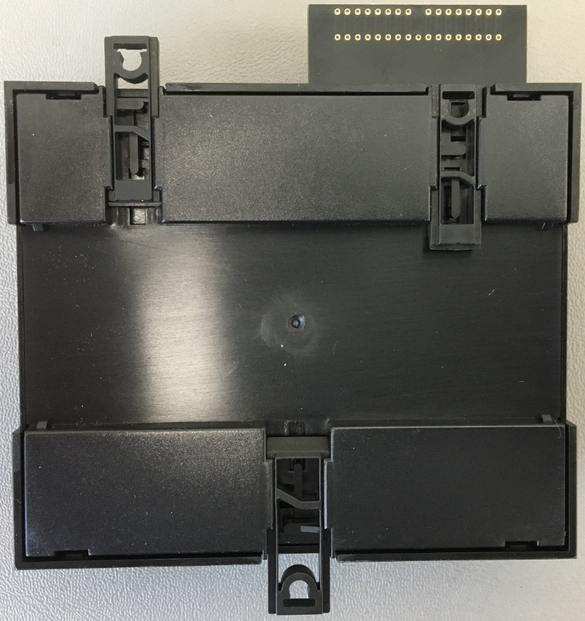

Figure 7: The top screw is shown mounted through the DIN clip to the wall: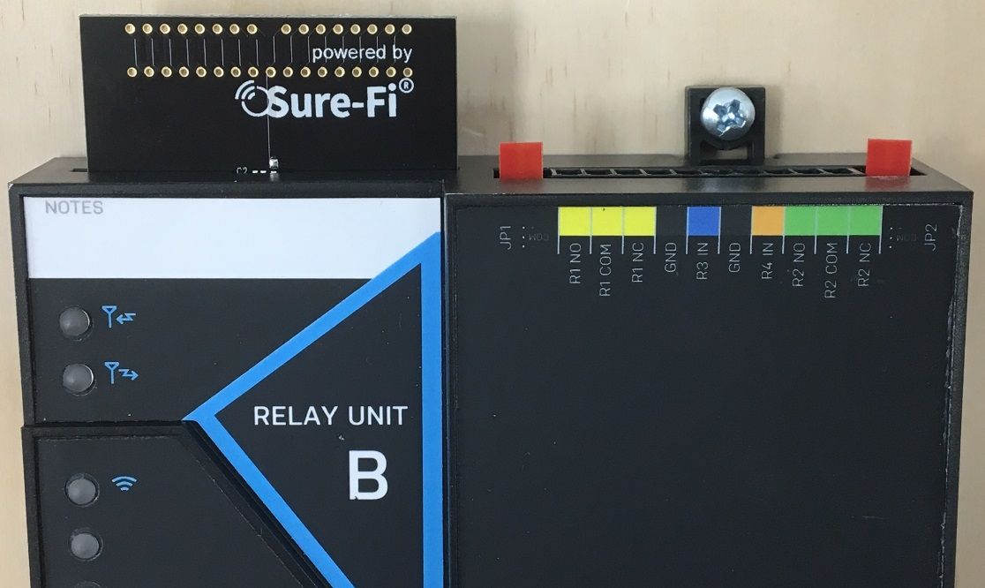

Figure 8: The bottom screw is shown mounted through the black DIN clip to the wall:
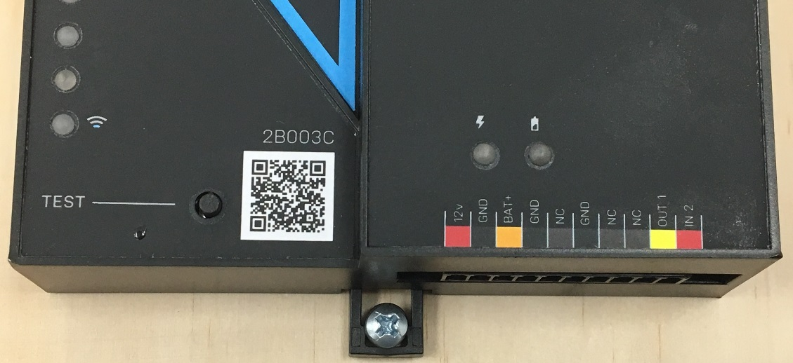

Troubleshooting
Testing Range and RF communications
Press and release quickly the ‘Test’ button on one of the units and observe the six Signal Strength LEDs. If any of the blue LED 1 through LED 6 lights up momentarily then the transmission between the two units was successful. This establishes that the radio communications between the two units is operational and even with only LED 1, there is adequate signal strength for proper function.

For the best range performance between the two units
- Power both units with their own dedicated power supply with a minimum of 1A @ 12VDC.
- Route all cables and wiring away from the area near the Antenna.
- Avoid routing cables and wiring over the top of the unit.
- Mount both units oriented with the antenna at the top of the unit facing upwards.
- Rotating either (or both) of the units may provide an improvement in range.
- If additional range is required, avoid placing either unit on or near metal and place each unit at a higher location.

Manually Testing Relays
Each Relay pair can be manually tested to verify operation. Using a jumper wire, short the Relay input, such as R1 IN to GND on Unit A, then monitor the Relay 1 OUTPUT on Unit B. This can be done with all four relays. Remember, Relay 1 and Relay 2 on Unit B are solid state type and a ‘click’ will not be heard when these two relays activate and so a meter or device would need to be connected to verify relay activation.

Wiring Example
Figure 9: Unit B: Wiring a powered device (Door-Strke) to Relay 1(R1 NO/ R1 COM) dry contact, a Push-button in to Relay 4 (R4 IN) input, and a door position sensor to the IN2 digital input.
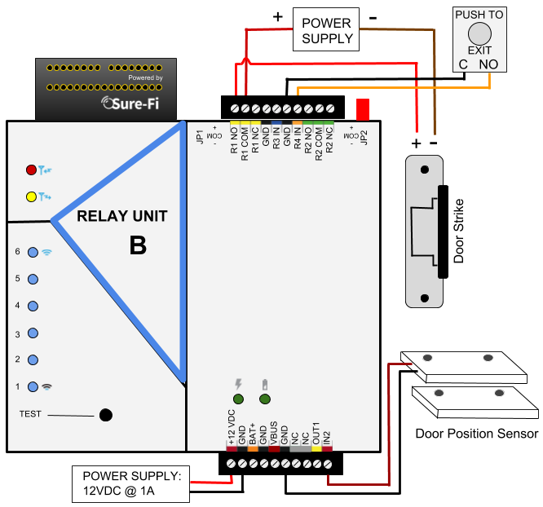
Figure 10: Unit A: Wiring Relay 1 control input (R1 IN), Push-button input, and Door sensor to the control panel input.
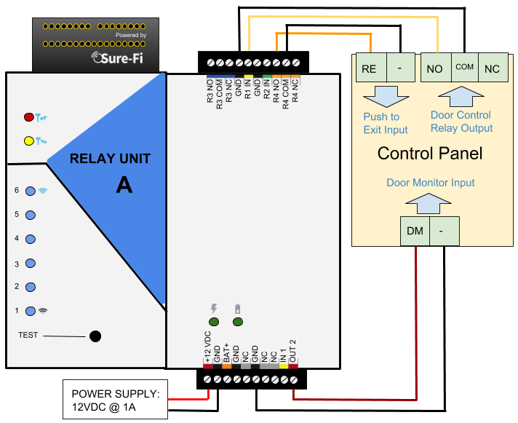
Chained Systems
Figure 11: Chained systems wiring diagram
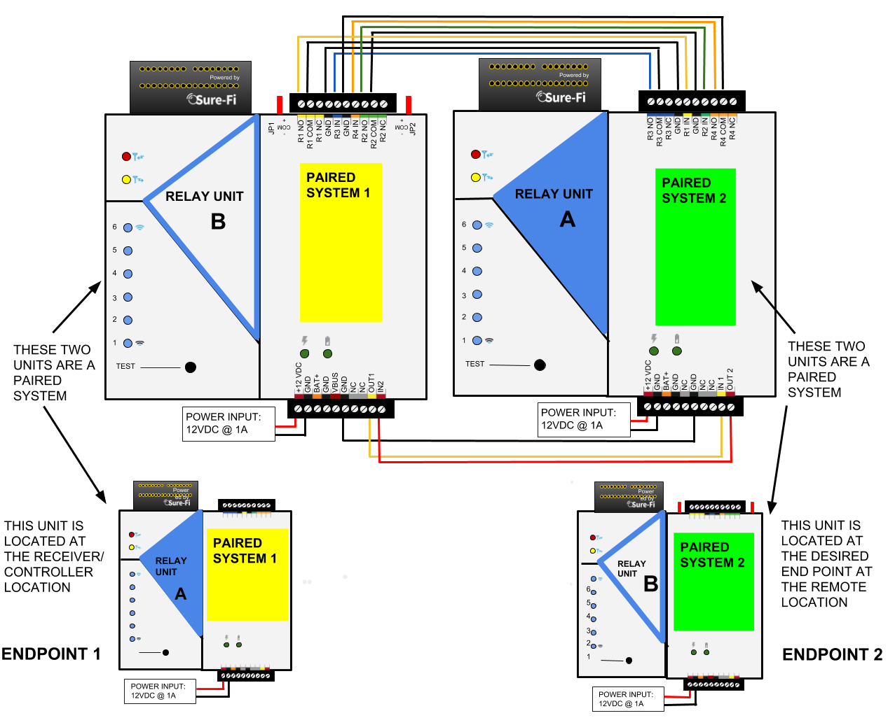

Sure-Fi App
The Sure-Fi App for iOS and Android allows for firmware updates, configuration and customization as well as for some diagnostics and troubleshooting information. The App is continually being updated to provide for more information and features and to improve its ease of use. To download, search for ‘Sure-Fi’ and then download and install. The key features of the App are:
- Field firmware updates
- Creating a custom / unique name for the unit location
- Configure the six Signal Strength LED indicators for ON/OFF, persistence time (default is ON, 1 second)
- Setting default Relay output values upon a set timeout interval (in increments of the Heartbeat time).
- Changing the system Heartbeat time.
- Diagnostics and Troubleshooting information
- Access to documentation (Operators Manual, Application Notes, Reference documents, etc.)

Using the Sure-Fi App
Connecting:
The Sure-Fi App uses the Bluetooth on the user’s phone to connect to the Bridge’s onboard Bluetooth interface. To use the App, be sure that the unit is powered ON, then open the App, then scan the QR code that is on the unit next the ‘TEST’ button. The Status will show ‘Connecting’, then after a pause it will say “Hold Test button on the Bridge for 5 seconds”. If the connection is successful, the status will show ‘Status: Connected’ and all the features of the App will be available for use.

Firmware Updating
Firmware updates must be completed on both units when updating the firmware. The Bridge pair may operate erratically or be non-functional until both sides have been updated to a new firmware version. If updating firmware on one side, plan to immediately go to the other side and perform the same firmware update.

A data connection must be available on the device (phone) that the Sure-FI App is running on. Be sure that the App remains connected to the Bridge unit during the update process which usually takes a couple minutes to complete. After connecting to the Bridge unit with the App, select ‘Update Firmware’ from the menu. The ‘Update Firmware’ screen will show the current firmware versions and show if a newer released version is available. Select ‘Start Firmware Update” to begin the updating process. A notification will be given when the update is complete. When complete, close the App and then power-cycle the unit.

Sure-Fi App (Cont.)
Change the name of the unit
On the main screen, tap the ‘edit’ icon, then enter the new name for the unit.

Setting the System Heartbeat time
The system Heartbeat is the time interval when the system will automatically perform a system status check if there have not been radio communications between the units during that time. The Heartbeat timer is reset each time any successful transmission occurs between units during regular usage. The Heartbeat system status check verifies communication between units and that all output states correspond correctly with the given inputs. If a unit does not receive the Heartbeat, it will continue to attempt communications and it will keep all outputs set at their current state unless any of the outputs have been set for fail-safe values using the App. In that case, the unit will set the output values as configured when the set time interval is reached. The Heartbeat time interval and the number of Heartbeats that can be missed are configurable with the App.

Setting a Relay default state, timeout, and setting an Alert Relay
This feature is defaulted from the factory as disabled. With Relay default state disabled, the relays will remain in their current state during any time that communications with the paired unit are interrupted. The relays can be set to default as activated or deactivated after a set time interval has passed if communication with the paired unit is interrupted. The time interval is based on multiples of the Heartbeat time. When the time interval is reached, the relay(s) will go to the selected default state (activated or deactivated) as configured in the App and will remain in that state until regular system activity returns. This feature provides a way to define the relay default state if communications between units is interrupted for a period of one or more Heartbeat time intervals and allows for a way to have a relay to be set as an ‘Alert’ Relay to indicate RF communications interruption.

FCC and Industry Canada Regulatory Statements
FCC
This device complies with part 15 of the FCC rules. Operation is subject to the following two conditions: (1) This device may not cause harmful interference, and (2) this device must accept any interference received, including interference that may cause undesired operation. Any changes or modifications not expressly approved by manufacturer could void the user’s authority to operate the equipment.

IMPORTANT! Any changes or modifications not expressly approved by the party responsible for compliance could void the user’s authority to operate this equipment.

Industry Canada
This device complies with Industry Canada license-exempt RSS standard(s). Operation is subject
to the following two conditions: (1) this device may not cause interference, and (2) this device
must accept any interference, including interference that may cause undesired operation of the
device.

Le présent appareil est conforme aux CNR d’Industrie Canada applicables aux appareils radio exempts de licence. L’exploitation est autorisée aux deux conditions suivantes: (1) l’appareil ne doit pas produire de brouillage, et (2) l’utilisateur de l’appareil doit accepter tout brouillage radioélectrique subi, meme si le brouillage est susceptible d’en compromettre le fonctionnement.

IMPORTANT! Tous les changements ou modifications pas expressément approuvés par la partie responsable de la conformité ont pu vider l’autorité de l’utilisateur pour actioner cet équipment.

47 CFR 15.105- FCC
NOTE: This equipment has been tested and found to comply with the limits for a Class B digital device, pursuant to part 15 of the FCC Rules. These limits are designed to provide reasonable protection against harmful interference in a residential installation. This equipment generates, uses and can radiate radio frequency energy and, if not installed and used in accordance with the instructions, may cause harmful interference to radio communications. However, there is no guarantee that interference will not occur in a particular installation. If this equipment does cause harmful interference to radio or television reception, which can be determined by turning the equipment off and on, the user is encouraged to try to correct the interference by one or more of the following measures:

—Reorient or relocate the receiving antenna.
—Increase the separation between the equipment and receiver.
—Connect the equipment into an outlet on a circuit different from that to which the receiver
is connected.
—Consult the dealer or an experienced radio/ TV technician for help.

This Class B digital apparatus complies with Canadian ICES-003.
Cet appareil numérique de la classe B est conforme à la norme NMB-003 du Canada

FCC Radiation Exposure Statement
This equipment complies with FCC radiation exposure limits set forth for an uncontrolled environment. This equipment should be installed and operated with minimum distance 20cm between the radiator and your body.

Important Note:
Radiation Exposure Statement:
This equipment complies with IC radiation exposure limits set forth for an uncontrolled environment. This equipment should be installed and operated with minimum distance 20cm between the radiator and your body.

Note Importante: (Pour l’utilisation de dispositifs mobiles)
Declaration d’exposition aus radiations:
Cet équipement est conforme aux limites d´exposition aux rayonnements IC établies pour un environnement non contrôlé. Cet équipment doit être installé et utilisé avec un mimimum de 20 cm de distance entre la source de rayonnement et votre corps.

Warranty
The warranty period of this product is 12 months run-time, beginning from first power up of the device after purchase. During this period, if the product does not operate correctly, due to a defective component, the product will be repaired or replaced at the sole discretion of Sure-Fi, Inc. This warranty does not extend to the product casing which can be damaged by conditions outside of the control of Sure-Fi, Inc.

EXCEPT AS SET FORTH ABOVE, SURE-FI, INC. MAKES NO WARRANTIES REGARDING THE GOODS, EXPRESS OR IMPLIED, INCLUDING WARRANTY OF MERCHANTABILITY OR WARRANTY OF FITNESS FOR A PARTICULAR PURPOSE. BUYER MAKES NO RELIANCE ON ANY REPRESENTATION OF SURE-FI, INC., EXPRESS OR IMPLIED, WITH REGARD TO THE GOODS AND ACCEPTS THEM “AS-IS/WHERE-IS”. SURE-FI, INC SELLS THE GOODS TO BUYER ON CONDITION THAT SURE-FI, INC. WILL HAVE NO LIABILITY OF ANY KIND AS A RESULT OF THE SALE. BUYER AGREES THAT SURE-FI, INC. SHALL HAVE NO LIABILITY FOR DAMAGES OF ANY KIND, WHETHER DIRECT, INCIDENTAL OR CONSEQUENTIAL DAMAGES, INCLUDING INJURIES TO PERSONS OR PROPERTY, TO BUYER, ITS EMPLOYEES OR AGENTS, AS A RESULT OF THE SALE. BUYER ALSO AGREES TO HOLD SURE-FI, INC. HARMLESS FROM ANY CLAIMS BUYER, OR ANY THIRD PARTY, MAY HAVE AS A RESULT OF BUYER’S USE OR DISPOSAL OF THE GOODS. BUYER HAS READ THIS DISCLAIMER AND AGREES WITH ITS TERMS IN CONSIDERATION OF RECEIVING THE GOODS.

Trademarks
Sure‐Fi and the Sure‐Fi logo are registered trademarks.

Copyrights
©2018 Sure‐Fi, Inc. All rights reserved.

